**FULL APPLICATION**

**TEMPLATE with instructions for project descriptions within the field of Strategic Vehicle Research and Innovation (FFI) Accelerate.**

The total number of pages in the project description should not exceed **21** (excluding cover page, summary, table of contents) in font size 11. The project description constitutes the primary basis for assessing and reviewing the quality of an application.

Applicants are recommended to read the FFI roadmap and other information that can be found on the FFI website, <https://ffisweden.se/en>, before writing their applications.

The applications that meet the formal requirements will be assessed by an external quality review group appointed by Vinnova. The review group adheres to professional secrecy as if they were under the employment of Vinnova.

If the planned project is a *technology demonstration* and that challenges are largely absent regarding business models, infrastructure, regulations and standards as well as behavior, then FFI Accelerate is probably not the right subprogram for the application. However, it may be a relevant application to one of the other sub-programmes.

*This page along with tips and information written in cursive format should be deleted before submitting your application.*

**Application within FFI Accelerate**

**<Insert the title of your project here>**

Is it a reworked application that has previously been assessed by the FFI quality review group?

Yes  No

If yes, specify the reference number:

Describe shortly what is new or changed compared with the previous application:

# Summary

Your text here...

*The summary must be no more than one page long and include:*

* *Background and goals of the project: what problem is to be solved, what the project is expected to achieve (what benefits) and who is the intended user.*
* *The potential of the project, in particular the different system perspectives:*
* *Behaviour, culture*
* *Business models*
* *Regulatory framework and standardisation (”policy”)*
* *Infrastructure, physical and digital*
* *Technology, products, services and processes*
* *State-of-the art*
* *Implementation and utilization, including the duration of the project and the total cost and funding applied for.*
* *Actors:*
* *Which party/organization is the main applicant (coordinator), responsible for submitting the application and who is then responsible for communication with and reporting within the program.*
* *Other partners involved in the project.*

Table of contents

Summary

Background and goals for the project 1

Potential 1

State-of-the-art 1

Feasibility 2

Project contents 2

Scheduling 2

Project financing 3

Utilization 4

Actors 4

Equality 4

References 5

Right-click the table of contents to find the function for updating contents and page numbers.

You have three levels of headings at your disposal (Heading 1, 2 and 3).

# 

# Background and goals for the project

Your text here...

* Provide a background for the project and clearly describe what/which problems or needs the project aims to address and the scope of the problems or needs, describe hypotheses/research issues, especially the five system perspectives:
* *Behaviour, culture*
* *Business models*
* *Regulatory framework and standardisation (”policy”)*
* *Infrastructure, physical and digital*
* *Technology, products, services and processes*
* If possible, specify concrete and measurable objectives for the project (for example, x % reduction in energy consumption or reduction in fatal road accidents).
* Describe the projects innovation level within the relevant field of application, for example what new knowledge is produced or what current knowledge is applied in new contexts. Shortly describe the preparatory project that was completed before this application.

# Potential

Your text here…

*Describe the following:*

* *The potential of the project to contribute to the sub-program as described in FFI's roadmap, in particular the system perspectives:*
  + Behavior, culture
  + Business models
  + Regulatory framework and standardization ("policy")
  + Infrastructure, physical and digital
  + Technology, products, services and processes
* *If the project refers to a mature field of study, does the project lead to large potential improvements in line with the FFI roadmap?*

# State-of-the-art

Your text here...

Give a short description how the project relates to the current national and international state of the art of the research/technology field. If a list of references is added, it is to be placed last in the document.

From the preparatory project, clearly state what results have been achieved and how they are used and influence this system demonstrator project. Final report from the preparatory project must be submitted as an attachment.

|  |
| --- |
| Project number: |
| Title: |
| Programme affiliation: |
| Decision-making agency: |

# Feasibility

## Project contents

Your text here...

Describe the content and setup of the project. The description should embrace different work packages content, role and responsibility of work packet leaders and other participants and defined deliverables/milestones. Describe how the work packages will be evaluated against the set goals.

The system demonstrator addresses the system challenges (describe):

* Behaviour, culture
* Business models
* Regulatory framework and standardisation ("policy")
* Infrastructure, physical and digital.
* Technology, products, services and processes.

Also describe working and research methodology (scientific hypothesis and methods where it is relevant).

Then give a more detailed description of the contents of each respective activity/work package and specify who does what. Feel free to use the format below:

|  |  |
| --- | --- |
| **<Work Package (WP) no X>** | **<Name of activity/work package (WP)>** |
| Leader (role and responsibility) |  |
| Other participants (roles and responsibilities) |  |
| Description of contents |  |
| Method/approach (when relevant) |  |
| Delivery and evaluation |  |

## Scheduling

Your text here...

Specify the project time schedule, start and end dates, showing important activities/work packages and milestones, as well as when different deliveries can be expected. A simple Gantt diagram and a table of milestones, as shown in the example below, may be helpful.

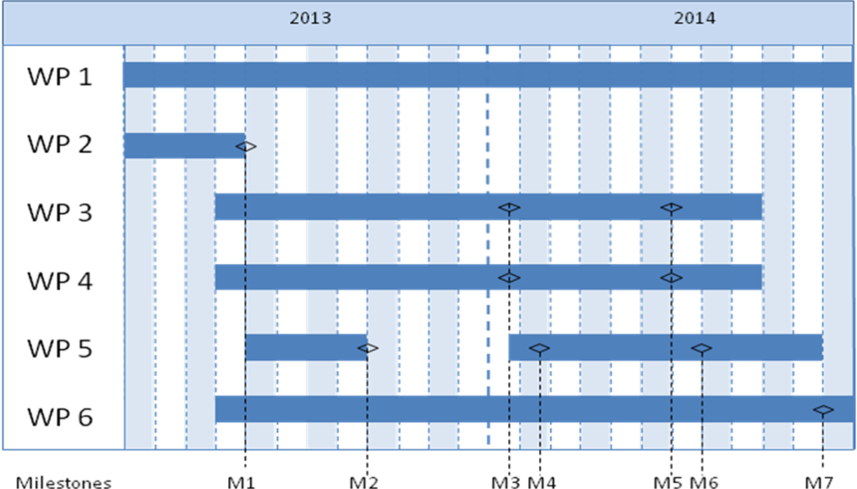

|  |  |  |
| --- | --- | --- |
| Milestone | Description | Date |
| M1 |  |  |
| M2 |  |  |
| M3 |  |  |
| Mxx |  |  |

## Project financing

Your text here...

*The project financing per work package should be presented in the table below.*

|  |  |  |  |  |  |  |  |
| --- | --- | --- | --- | --- | --- | --- | --- |
|  | | Budget per participating party | | | | | Total budget/WP |
|  | | <Party 1> | | <Party 2> | | <Party x> |  |
| <WP1> | |  | |  | |  |  |
| <WP2> | |  | |  | |  |  |
| <WPx> | |  | |  | |  |  |
| TOTAL budget per part |  | |  | |  | |  |

*The table below can be used to specify the type of costs arising in the project.*

|  |  |
| --- | --- |
| Cost specification | Description |
| Equipment, facilities |  |
| Consultancy costs, licenses |  |
| Other direct costs incl. travelling costs |  |
| Other costs |  |

## Utilization

Your text here...

*Describe how the project intends to realize the potential of and disseminate/utilize the results. How are results and experiences communicated, how have the target groups been chosen.*

# Actors

Your text here….

Describe how the project management will be organized.

**Tabell 1. Projekt parties**

|  |  |  |  |  |
| --- | --- | --- | --- | --- |
| Organisation | Role i the project | Number of person hours: estimated for the entire project time | Total personnel cost for the organization's project participation, including indirect cost | |
|  |  |  |  |
|  |  |  |  |
|  |  |  |  |
|  |  |  |  |
|  |  |  |  |

Explain why each project party is an important part of the consortium and the role of the project party.

*CV (according to template available at the page for the call at vinnova.se) needs to be submitted for the project manager, work package leaders and other key personnel so that the project participants competence and abilities can be assessed.*

*Other relevant information about the parties can also be submitted here.*

*If sub-contractors are to be procured (for example consultants) this must be specified along with the purpose and extent of their involvement in the project.*

*Specify the actors who are linked to the project in one way or another but who are not project parties. For example, it can be organizations that are part of a reference group. Describe their role and the extent to which they are involved in the project, including the names and functions of the contact persons.*

# Equality

Your text here….

*Many problems, results and solutions can seem to be gender neutral, but they still affect women and men differently.*

* *Describe how the project team is composed regarding gender distribution, but also the distribution of power and influence between men and women.*
* *Describe how equality aspects have been integrated in the project.*
* *Describe equality aspects (gender and gender perspective) that can be important to take into consideration in relation to the projects field of study, solutions, and effects.*

*Enter the gender distribution in the project in the table below. Suggest relevant working methods for managing gender equality in the project if the distribution is not at least 60 % / 40 %.*

|  |  |  |  |
| --- | --- | --- | --- |
|  | Proportion of men and women working in the project | Proportion of work (hours) performed by men and women respectively | Proportion of men and women in decision-making positions in the project |
| Men | % | % | % |
| Women | % | % | % |
| Total | 100 % | 100 % | 100 % |

# References

*List your references (scientific publications, monographs, conference articles etc.) here. Be restrictive when referring to websites as these have not been “quality reviewed” in the same ways as a publication and the addresses have a tendency to quickly become obsolete.*

The “References” section can be omitted if it is not needed.